System Design

🌟 Definition
# Source: AI Source: Provided by: [Data Path: Persons Table -> ID Column: 1, Name_En Column: Motasem Essam] -> From: [ChatGPT] on [6/7/2026]
System Design is the third phase of the Software Development Life Cycle (SDLC) where the approved requirements are transformed into a detailed technical blueprint that explains how the software system will be built.
The main question in this phase is:
"How will we build the system?"

🎯 Purpose of System Design
# Source: AI Source: Provided by: [Data Path: Persons Table -> ID Column: 1, Name_En Column: Motasem Essam] -> From: [ChatGPT] on [6/7/2026]
The goals of the Design phase are to:
- Define the software architecture
- Design the database structure
- Design user interfaces
- Select technologies and tools
- Define system components and interactions
- Prepare a blueprint for developers

🔄 System Design Process
# Source: AI Source: Provided by: [Data Path: Persons Table -> ID Column: 1, Name_En Column: Motasem Essam] -> From: [ChatGPT] on [6/7/2026]
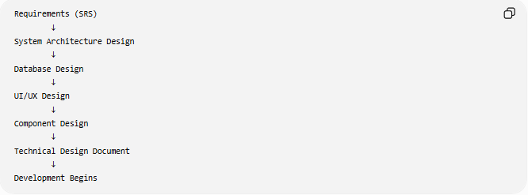
Requirements (SRS)
↓
System Architecture Design
↓
Database Design
↓
UI/UX Design
↓
Component Design
↓
Technical Design Document
↓
Development Begins

🧩 Main Activities in System Design

1️⃣ System Architecture Design
# Source: AI Source: Provided by: [Data Path: Persons Table -> ID Column: 1, Name_En Column: Motasem Essam] -> From: [ChatGPT] on [6/7/2026]
Definition
Defines the overall structure of the software system and how different parts communicate.

Common Architectures
Client-Server Architecture
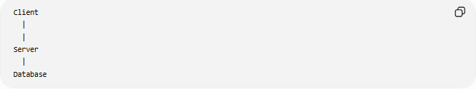
Client
|
|
Server
|
Database
Example:
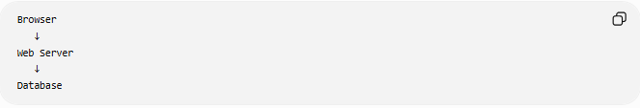
Browser
↓
Web Server
↓
Database

Three-Tier Architecture
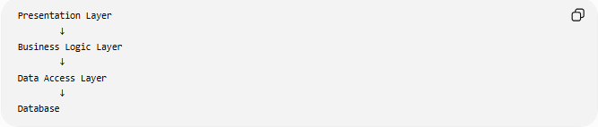
Presentation Layer
↓
Business Logic Layer
↓
Data Access Layer
↓
Database

Microservices Architecture
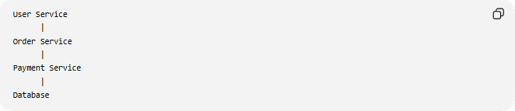
User Service
|
Order Service
|
Payment Service
|
Database

2️⃣ Database Design
# Source: AI Source: Provided by: [Data Path: Persons Table -> ID Column: 1, Name_En Column: Motasem Essam] -> From: [ChatGPT] on [6/7/2026]
Definition
Designing how data will be stored, organized, and accessed.

Activities:
- Define tables
- Define columns
- Choose data types
- Define relationships
- Create constraints

Example:
Customer Table
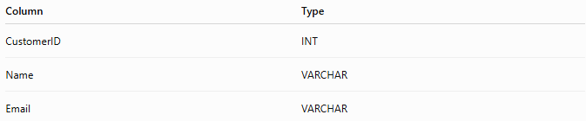
Column | Type
CustomerID | INT
Name | VARCHAR
Email | VARCHAR

Relationship:
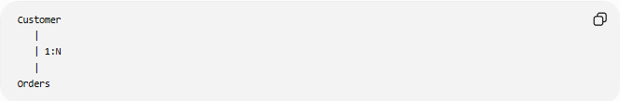
Customer
|
| 1:N
|
Orders

3️⃣ User Interface (UI) Design
# Source: AI Source: Provided by: [Data Path: Persons Table -> ID Column: 1, Name_En Column: Motasem Essam] -> From: [ChatGPT] on [6/7/2026]
Definition
Designing how users interact with the software.

Includes:
- Screen layouts
- Buttons
- Forms
- Navigation
- User experience

Example:
Login Screen:
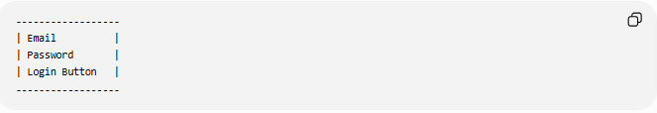
------------------
| Email |
| Password |
| Login Button |
------------------

4️⃣ Component Design
# Source: AI Source: Provided by: [Data Path: Persons Table -> ID Column: 1, Name_En Column: Motasem Essam] -> From: [ChatGPT] on [6/7/2026]
Definition
Breaking the system into smaller modules/components.

Example:
E-Commerce System:
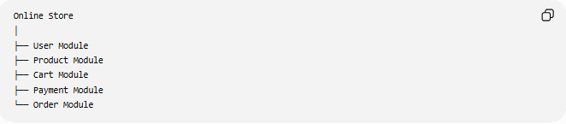
Online Store
│
├── User Module
├── Product Module
├── Cart Module
├── Payment Module
└── Order Module

5️⃣ API Design
# Source: AI Source: Provided by: [Data Path: Persons Table -> ID Column: 1, Name_En Column: Motasem Essam] -> From: [ChatGPT] on [6/7/2026]
Definition
Defines how different software components communicate.

Example:
User Login API:
POST /api/login
Request:
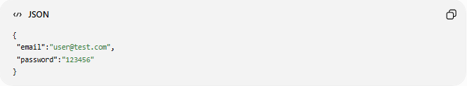
{
"email":"user@test.com",
"password":"123456"
}
Response:
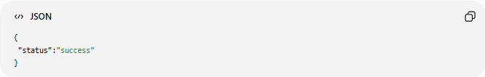
{
"status":"success"
}

6️⃣ Security Design
# Source: AI Source: Provided by: [Data Path: Persons Table -> ID Column: 1, Name_En Column: Motasem Essam] -> From: [ChatGPT] on [6/7/2026]
Definition
Planning security controls before development.

Includes:
- Authentication
- Authorization
- Encryption
- Data protection
- Access control

Example:
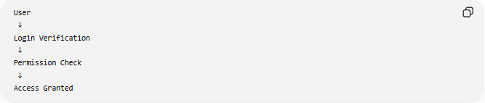
User
↓
Login Verification
↓
Permission Check
↓
Access Granted

7️⃣ Technology Selection
# Source: AI Source: Provided by: [Data Path: Persons Table -> ID Column: 1, Name_En Column: Motasem Essam] -> From: [ChatGPT] on [6/7/2026]
Choosing tools and technologies.

Example:
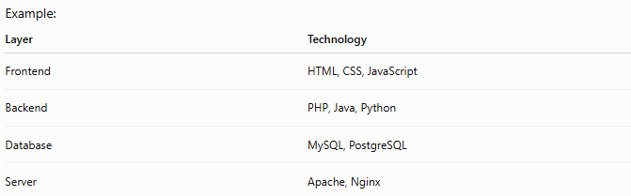
Layer | Technology
Frontend | HTML, CSS, JavaScript
Backend | PHP, Java, Python
Database | MySQL, PostgreSQL
Server | Apache, Nginx

📚 Design Documents
# Source: AI Source: Provided by: [Data Path: Persons Table -> ID Column: 1, Name_En Column: Motasem Essam] -> From: [ChatGPT] on [6/7/2026]
Common documents created:
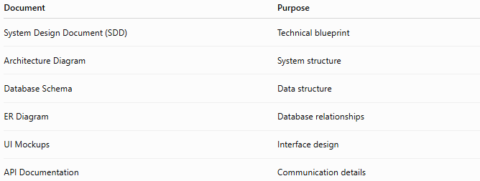
Document | Purpose
System Design Document (SDD) | Technical blueprint
Architecture Diagram | System structure
Database Schema | Data structure
ER Diagram | Database relationships
UI Mockups | Interface design
API Documentation | Communication details

🔍 Design Types

1️⃣ High-Level Design (HLD)
# Source: AI Source: Provided by: [Data Path: Persons Table -> ID Column: 1, Name_En Column: Motasem Essam] -> From: [ChatGPT] on [6/7/2026]
Focuses on the overall system.
Includes:
- Architecture
- Major components
- Technology choices
Example:
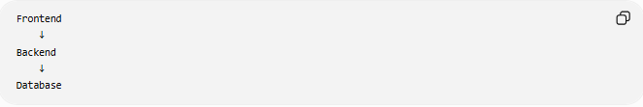
Frontend
↓
Backend
↓
Database

2️⃣ Low-Level Design (LLD)
# Source: AI Source: Provided by: [Data Path: Persons Table -> ID Column: 1, Name_En Column: Motasem Essam] -> From: [ChatGPT] on [6/7/2026]
Focuses on detailed implementation.
Includes:
- Classes
- Functions
- Algorithms
- Database details
Example:
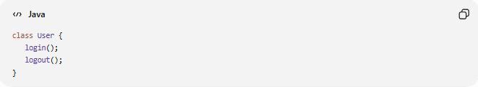
class User {
login();
logout();
}

📊 HLD vs LLD
# Source: AI Source: Provided by: [Data Path: Persons Table -> ID Column: 1, Name_En Column: Motasem Essam] -> From: [ChatGPT] on [6/7/2026]
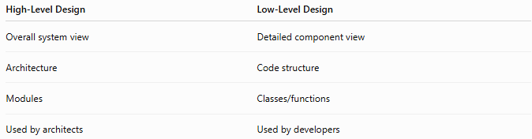
High-Level Design | Low-Level Design
Overall system view | Detailed component view
Architecture | Code structure
Modules | Classes/functions
Used by architects | Used by developers

🛠️ Tools Used in System Design
# Source: AI Source: Provided by: [Data Path: Persons Table -> ID Column: 1, Name_En Column: Motasem Essam] -> From: [ChatGPT] on [6/7/2026]
Examples:
- Microsoft Visio — Architecture diagrams
- Figma — UI prototypes
- Lucidchart — System diagrams

📊 Output of System Design
# Source: AI Source: Provided by: [Data Path: Persons Table -> ID Column: 1, Name_En Column: Motasem Essam] -> From: [ChatGPT] on [6/7/2026]
At the end of this phase:
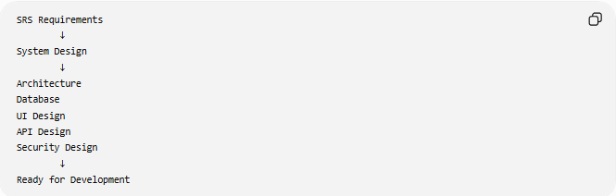
SRS Requirements
↓
System Design
↓
Architecture
Database
UI Design
API Design
Security Design
↓
Ready for Development

🧠 Simple Analogy
# Source: AI Source: Provided by: [Data Path: Persons Table -> ID Column: 1, Name_En Column: Motasem Essam] -> From: [ChatGPT] on [6/7/2026]
Building a house:
Design Phase
After knowing requirements:
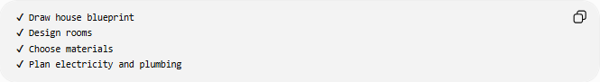
✔ Draw house blueprint
✔ Design rooms
✔ Choose materials
✔ Plan electricity and plumbing
Software equivalent:
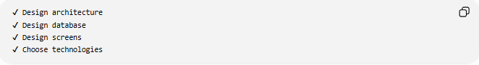
✔ Design architecture
✔ Design database
✔ Design screens
✔ Choose technologies

🧭 Summary
# Source: AI Source: Provided by: [Data Path: Persons Table -> ID Column: 1, Name_En Column: Motasem Essam] -> From: [ChatGPT] on [6/7/2026]
The System Design Phase of SDLC converts software requirements into a detailed technical plan. It defines the system architecture, database design, user interface, components, APIs, security, and technologies required to build the software. The output is a complete design blueprint that guides developers during the implementation phase.

